**BRAND CLASSIFICATION AND COUNTERFEIT DETECTION OF MEDICINE IN NIGERIA: A CONVOLUTIONAL NEURAL NETWORK HYBRID APPROACH**

**1\*Martins E. Irhebhude, 2Adeola O. Kolawole and 3Zubair Momoh Wali**123Department of Computer Science, Nigerian Defence Academy, Kaduna  
\*Corresponding author: mirhebhude@nda.edu.ng

**Abstract**

This study tackled the critical public health threat of counterfeit drugs in Nigeria's pharmaceutical industry. Deceptive medicines, containing incorrect or harmful ingredients, are difficult to identify and have a significant impact on low- and middle-income countries, where estimates suggest over 10% of medicines are fake. To combat this issue, a CNN Hybrid model was developed to analyze a self-captured dataset of medicine packages in the form of images and National Agency for Food and Drug Administration Control (NAFDAC) numbers. Only 10 of Nigeria's registered pharmaceutical brands were taken into consideration due to the availability of products. Few samples of counterfeit drugs were obtained from NAFDAC. Other samples were constructed using adapted techniques from existing studies; this was achieved by modifying the original graphics slightly to create the counterfeit logos. The proposed model leveraged pre-trained deep learning architectures, ResNet-50 and VGG16 (V16RN-50), to extract features from the images that were used for classification. The extracted features were concatenated and fed into the custom trainable dense and output layer designed to identify counterfeit and real medicines. The model achieved an impressive result in multi-classification with a training accuracy of 95.83%, a validation accuracy of 94.82%, and a test accuracy of 95.1%. Counterfeit medicine detection also yielded an excellent training accuracy of 98.8%, a validation accuracy of 98.1%, and a test accuracy of 97.3%. The findings were further strengthened by high precision, recall, and F1-score metrics of 0.951, 0.951, and 0.951 for brand recognition and 0.973, 0.973, and 0.973 for detection of counterfeit medicines respectively. Additionally, the model outperformed the benchmark studies in counterfeit detection. The research demonstrated the potential of the proposed models to detect counterfeit drugs and contribute to improved public health in Nigeria**.**

**Keywords:** CNN Hybrid, V16RN-50, Counterfeit Medicine, Medicine Brand, Medicine Logo

1. **INTRODUCTION**

Globally, counterfeiting is a significant and complex concern since it impacts a vast range of products that can be copied and sold for profit. It is rather alarming that counterfeit medical supplies and equipment have been targeted in Nigeria. The erstwhile head of Nigeria’s Food and Drug Administration Control (NAFDAC), the late Dora Akunyili maintained that *“counterfeiting of drugs, quite candidly is one of the greatest crimes of this era, as it is mass homicide, a form of extremism against public health, an action that amounts to economic sabotage, and a violation of the right to life of innocent persons who are victims”* (Crews, 2018).

According to Isles (2017) arugs that are fake, counterfeit, or contain deceptive labels are often classified as substandard products by the World Health Organization (WHO); however, not all substandard products fit into this category. According to Adigwe et al. (2022), pharmaceuticals and drugs that are counterfeit can pose a major risk to public health because they are usually marketed misleadingly. This is particularly true in terms of their efficacy, source, and validity. Contraband medical pharmaceuticals are defined as false claims about identity and/or source, although the phrase "fake drugs" is the most useful for educating the public about pharmaceutical drug counterfeiting. Counterfeit or fraudulent drugs can be defined as products with improper components, no active ingredients, an erroneous amount of active substances, or falsified packaging (Klantschnig & Huang, 2019). Since they frequently don't meet quality requirements, fake drugs have become a major threat to public health across Africa (Ekeh & Adekoya, 2021).

Based on existing data, counterfeiting is a major threat to the integrity of the healthcare delivery system and the jobs held by pharmacists (Adigwe et al., 2022). The data presented above shows a discernible rise in the incidence of counterfeit drugs, which is reason for growing alarm. For the purpose of detecting counterfeit medications, a range of systems and procedures have been proposed and approved, including lab test-based techniques like Test-tube Color Reaction, Melting Point Determination, Thin Layer Chromatography (TLC), Rapid Counterfeit Medicines Detection Method, and Analytical Techniques for Sophisticated Counterfeits (Davison, 2011). Moreover, this goal has guided the development of complex technological instruments like the Black-eye Device, Mobile Authentication Service (MAS), and TruScan (Sherma, 2013). It is important to keep in mind that many of these methods are rather expensive and require certain training and expertise.

To halt the activities of individuals who counterfeit its regulated items, the NAFDAC redesigned its anti-counterfeiting protocols and put in place the NAFDAC Numbers, Mobile Authentication Services (MAS), and an RFID system (Obinna & Olawale, 2010). Furthermore, NAFDAC has battled counterfeit drugs by utilizing state-of-the-art technologies. One of the technologies is the portable TRUSCAN tool, which use Raman spectroscopy to identify bogus and inferior pharmaceuticals both in transit and at the border. The organization also plans to track registered products and remove unregistered ones using NAFDAC's Enforcement Directorate (Ezigbo, 2023). Despite efforts by law enforcement to target criminal organizations, Nigeria's drug industry continues to be a booming hub for the manufacture and sale of subpar and fake drugs (Okereke et al., 2021). Counterfeit goods may utilize false packaging that closely resembles the real thing to fool consumers. This emphasizes how important it is to carefully check the box when purchasing prescription medications (WHO, 2018).

Ferdosi et al. (2021) created a model in Bangladesh for identifying counterfeit medications using deep learning techniques. The model distinguished between real and phony medication brands using logo photos from drug manufacturing businesses. In terms of brand recognition, the model achieved 96% test accuracy, and in terms of fake detection, 84% test accuracy. The study found flaws in the methodology's complexity and recognition accuracy, including potential problems with computational resources and misclassifications in the brand recognition module.

In order to identify and recognize counterfeit pharmaceuticals using a hybrid CNN model, this study suggests an approach that uses photos of brand logos, color, texture, and NAFDAC numbers from medicine containers. The decision to combine two cutting-edge CNN transfer learning models was made because ResNet50, a 50-layer deep convolutional neural network model, uses a residual learning framework to address the vanishing gradient problem that can arise in very deep networks, while VGG16, a deep neural network with 16 layers, can be computationally complex and have issues with vanishing gradients during training. By combining the two models, one can better understand data correlations and increase overall performance by utilizing the advantages of both VGG16 and ResNet-50.

The remainder of the paper is as follows: section II describes the transfer learning models. Related studies are reported in section III. The methodology is discussed in section IV. Section V discusses the experimental results. The summary of findings, conclusion, and recommendations, are described in section VI.

1. **TRANSFER LEARNING MODELS**

CNNs require large amounts of labeled training data in order to perform well. This is because the models involve millions of parameters that need to be learned from the data, and they require a significant amount of variation in the data to prevent overfitting (Krichen, 2023). The more data used for training, the better the model performs overall. However, collecting a large amount of labeled training data can be expensive and time-consuming, especially for tasks requiring precise segmentation or classification (Krichen, 2023). In some circumstances, transfer learning—which starts with a pre-trained model and refines it on a smaller dataset—can be a useful tactic.

Transfer learning is a popular and useful technique for training a network on a small dataset, while a network like ImageNet is pre-trained on an incredibly big dataset (Yamashita et al., 2018), which contains 1.4 million images with 1000 classes, it can then be reused and applied to the given task of interest. At the moment, the public can readily access a multitude of models—such as AlexNet, VGG, ResNet, Inception, DenseNet, and others—as well as their learning kernels and weights, having been pre-trained on the ImageNet challenge dataset (Yamashita et al., 2018).

The importance of ResNet and VGG models in the field of deep learning has been demonstrated by the extensive use of these models in several studies (Tey et al., 2023). The extensive study of ResNet and VGG in the literature shows their widespread application and effectiveness in tackling difficult deep learning tasks.

***Residual Network (ResNet)***

A CNN architecture called ResNet was created by (He et al., 2016), which presented the idea of residual connections as a solution to the deep network issue of disappearing gradients. (Irhebhude et al., 2023) (Irhebhude et al., 2023). The ResNet’s architecture uses residual mapping:

(1)

Where H(x) = Actual output,

F(x) = loss function and

x = Actual input.

Instead of learning a direct mapping

(2)

and these blocks are called residual bocks (Ghosh et al., 2020).

Each residual block in the ResNet architecture has shortcut connections and Conv\_Layers that add the original input to the block's output without going through the Conv\_Layers. The completely linked layers generate a probability distribution over the possible classes using a softmax activation function (Krichen, 2023).

The five versions of the ResNet model are ResNet18, ResNet34, ResNet50, ResNet101, and ResNet152. Various levels of convolutional blocks are employed in the various ResNet architectures(Mukherjee, 2022).

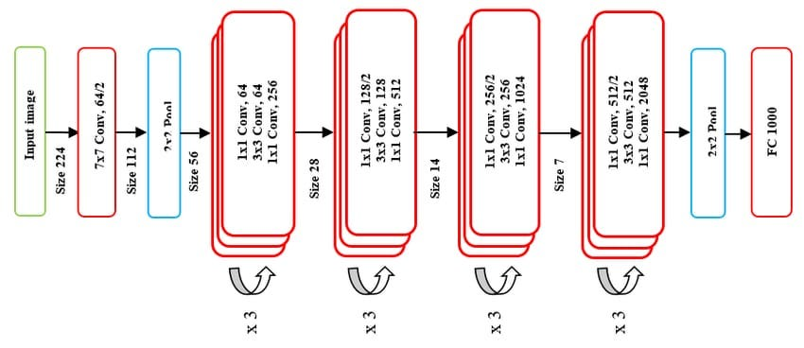

Figure 1: ResNet-50 Architecture (Mukherjee, 2022).

The model in Figure 1 uses standard-sized photographs as input, typically with 224 x 224 pixels. First, a 7x7 convolutional operation with 64 filters makes up the first layer. Batch normalization and rectified linear unit (ReLU) activation come next. Spatial dimensions are reduced via a 3×3 max-pooling layer. The residual block, which tackles the vanishing gradient issue in deep networks, is the main innovation in ResNet (He et al., 2016). Two 3x3 convolutional layers with batch normalization and ReLU activation are present in each residual block. By omitting one or more levels, shortcut links enable the gradient to pass through the network immediately. As one moves deeper into the network, ResNet-50 has multiple stacked residual blocks with progressively more filters (64, 128, 256, and 512).

Identity blocks are residual blocks that have a shortcut link that connects the input and output directly, and they lack a convolutional layer. (He et al., 2016). Identity blocks help to maintain the spatial resolution. The tensor is converted into a vector at the network's end by a global average pooling layer, which averages the spatial dimensions. The flattened vector is connected to a fully connected layer for the ultimate categorization. The output layer of a multi-class classification task usually has a softmax activation function that furnishes probability for every class. ResNet-50 stands out for its depth thanks to its total of 50 layers. The model has millions of parameters, which allow it to learn minute nuances.ResNet-50 is often initialized using pre-trained weights on large image datasets such as ImageNet. Through this pre-training, feature extraction is simplified. Without experiencing degradation difficulties, very deep networks can be trained thanks to the direct gradient flow enabled by the skip links or shortcuts (He et al., 2016).

**Visual Geometry Group (VGGNet)**

Another CNN architecture called VGG was created by (Simonyan & Zisserman, 2015), The VGGNet-16 (configuration D) and VGGNet-19 (configuration E) are the two most popular CNN configurations of the six that the authors presented (Ghosh et al., 2020). In the VGG architecture, the max Pool\_Layers layer is positioned after multiple layers of tiny 3 × 3 convolutional filters. The fully linked layers use dropout regularization and ReLU activation to prevent overfitting.

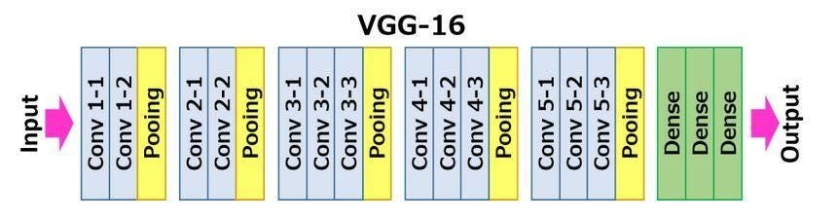

Figure 2: VGG-16 Architecture (Ibrahim et al., 2023).

The VGG16 architecture seen in Figure 2 consists of thirteen convolutional layers and three completely linked layers. Predictions based on the features retrieved from the input image by the convolutional layers are produced by the fully connected layers (Ibrahim et al., 2023).

ResNet has a lower complexity than popular VGGNets (22 layers), but being 8 times deeper (152 levels) than VGGNets (Krichen, 2023). However, ResNet—more specifically, ResNet-152, which has 152 layers—is far deeper than VGG16, which has 16 levels. ResNet's architecture makes use of skipping or residual connections to help lessen the vanishing gradient issue. This makes training the network easier, even with a large number of layers due to its enhanced depth. This design innovation allows ResNet to outperform VGGNets with deeper topologies while maintaining a lower computational complexity.

**III. RELATED LITERATURE**

A summary of some current and upcoming digital methods for identifying and recognizing pharmaceutical brands is given in this section. Throughout the years, a large number of writers (Ansari et al., 2018; Ferdosi et al., 2021; Kunduraci & Kahramanli̇, 2019; Motwani et al., 2022; Singh et al., 2020; Sreeja et al., 2023) have devoted considerable efforts to enhance the detection and recognition of brands using logos under different circumstances.

Islam & Islam (2022) used a Systematic Literature Review (SLR) methodology to examine all the pertinent research on using digital intervention to prevent or reduce the use of fake and counterfeit medications. From the original batch of 1253 papers, a total of 51 articles were examined using an inclusion-exclusion criterion. The review study concluded that, as a result, research and investigation of fake and fraudulent medications have become increasingly important. Several cutting-edge technologies (such as blockchain, the Internet of Things, RFID, image processing, pattern recognition, etc.) are being effectively employed to combat this problem. The assessment also identified areas for future research that could support ongoing efforts to stop the counterfeiting of medications. The implications of emerging technologies, the identification of contaminated points throughout the pharmaceutical supply chain, an examination of the less-emphasized issue of counterfeit and falsified medications, an examination of all potential use-cases or features of any digital solution to reduce counterfeit and falsified medications, and the creation of a system for reporting incidents involving counterfeit and falsified medications are some of the topics covered by this future research.

Mackey & Nayyar (2017) reviewed current and upcoming digital technologies in an effort to stop the international trafficking in counterfeit medications. The review's objective was to find innovative digital solutions that could strengthen and supplement more established security and anti-counterfeiting protocols. The authors classified technology into five categories: mobile, blockchain, RFID, online verification, sophisticated computational approaches, and online verification. Compared to more conventional security methods like package authentication, the research found that digital solutions might be more cost-effective to implement, more scalable, more user-friendly, and function in real-time. Digital anti-fake medication solutions are cohesive platforms that include several anti-counterfeiting technologies as supplementary measures, enhance data collection and exchange, and are engineered to surmount current adoption and implementation obstacles. To guarantee the security and integrity of the global medication supply chain in the future, investments in this next-generation technology are imperative.

Ferdosi et al. (2021) proposed a non-invasive alert system to distinguish approved pharmaceutical brands from counterfeit or banned brands using transfer learning with the pre-trained VGG-16 model.  
The system first identified whether the logo belonged to an approved brand and further checked the logo's authenticity. If the logo is not listed among approved brands or is identified as a banned brand or a fake, the system alerts the user about the potential presence of counterfeit medicine. The study utilized two datasets: Dataset 1, which contains logos from 17 out of 257 pharmaceutical companies in Bangladesh such as; Incepta, Beximco, ACI, and Square, and Dataset 2, which includes fake logos. The logos were collected from official websites, social media pages, and medicine stripes bought from drugstores. The collected logo images were trained using a pre-trained VGG-16 model with transfer learning for both brand recognition and fake logo detection. The model was trained with the brand recognition dataset to identify the pharmaceutical company from the logo image. Then, it was trained with the fake logo detection dataset to determine if the logo was real or fake. The CNN model was trained on both datasets and achieved 92% training accuracy 84% validation accuracy in brand recognition 96% test accuracy in brand recognition and 84% test accuracy in fake logo detection.

Daoud et al. (2020) created a machine learning-based system for spotting counterfeit items. The authors used pre-trained deep learning detection models, specifically Single Shot Multibox Detectors (SSD) and Faster Regional Convolutional Neural Networks (RCNN), using self-captured datasets. Text recognition and picture detection made up the majority of the trained model, which was designed to verify the authenticity of the mark or logo. The implementation was done in two stages: training and detection. The researchers gathered 2000 certification marks and logos from Testing, Inspection, and Certification (TIC) members' websites for the purpose of demonstration. (Daoud et al., 2020), including TÜV SÜD AG, Dekra, and Bureau Veritas. By utilizing Faster (RCNN) to extract certification marks and logos from video frames, the authors were able to further enhance the dataset. Following data collection, training (80%) and test (20%) sets of raw data were created and tagged using the annotation application “LabelImg”. The models that had already been trained were used for transfer learning. With a lower training pace, the faster RCNN achieved good accuracy (mean average precision of 83.8% on the VOC 07 test set). Similarly, SSD detected large objects—including logos—with remarkable speed and accuracy (average test time of 0.02 seconds per image and frame rate of 45 frames per second, assessed on the VOC 07 test set), albeit accuracy was not reported. The results of the detection, which demonstrated the potential of machine learning-based technology in the battle against counterfeiting, showed that each certificate mark could be detected with 97% precision in 3.1 seconds on 400 inspected data samples.

Motwani et al. (2022) suggested a strategy that makes use of deep learning algorithms to detect counterfeit medications. Their method involved looking at pictures of drug packaging to identify fake medications. Images of pharmaceutical packaging that were collected using web scraping programs like Scrapy and Selenium made up the dataset used by the researchers. To ensure an equal amount of real and fraudulent photos, they grabbed photographs of medications from ten different manufacturers. The system design involved using a Single Shot Multibox Detector (SSD) and Azure OCR Optical Character Recognition to analyze the logo and text on the medicine packages for authenticity. The input image of the medicine package was processed to detect the authenticity of the logo and verify the text, including the medicine name and composition, by querying a database (Firebase) for validation. Results showed the effectiveness of the proposed approach in detecting counterfeit medicines. The system was able to detect fake logos and verify the text on the medicine package, providing users with a result of "Real" or "Counterfeit" medicine. However, one of the drawbacks of this research is the lack of a comprehensive evaluation of the proposed system. The results of tests carried out on a dataset of medical images were reported in the publication, but a thorough examination of the evaluation metrics—such as precision, recall, and F1 score—that were used to gauge how well the deep learning models performed was not included.

Another study by Ting et al. (2020) Using Deep Learning algorithms, a drug recognition model was constructed in Taiwan. The study's findings showed that the front-side (pill shape and color) model required 5 hours and 34 minutes of training, whereas the back-side (textual pattern and logo) model required 7 hours and 42 minutes. Additionally, the model showed that the back-side model had an F1 score of 95.99% and the front-side model had an F1 score of 93.72%.

Sanghi et al. (2021) proposed a blockchain-based approach to track the movement of medications from the industry to the patient and lower the risk of a drug being counterfeit. The main reasons for using blockchain technology are its mutability and how simple it is to track an item in the network. The researchers used Hyperledger fabric, which has many auto-implemented capabilities, to develop this model. The successful application of the proposed blockchain-based methodology showed that it can detect any fake medication. The authors' reports were limited to three topics: the Hyperledger Fabric presentation of the medication supply chain, the approval and tracking of drug transportation, and the successful identification of counterfeit drugs.

The study by Upadhyay et al. (2023) proposed a method for identifying counterfeit pharmaceuticals using blockchain technology. The system maintains a decentralized ledger of all transactions and monitors a drug's life cycle from creation to delivery. The approach ensured that only legitimate medications were delivered to the designated place by allowing stakeholders to quickly verify the legality of medications. The effectiveness of the system in identifying fake medications was tested in a simulated setting, and the findings showed that the recommended approach may effectively identify fake medications with high accuracy and dependability.

Trenfield et al. (2019) revealed the first-ever single-step interface between 2D inkjet and 3D printing technologies to create a drug-loaded 3D printed tablet (printlet) with a special track-and-trace feature. In order to scan polymeric-based printlets with a smartphone, the study printed quick response (QR) codes and data matrices on their surface. These codes encoded customized information about the drug product, patient, and provider. Additionally, a novel anti-counterfeit technique was devised by the study, which required the deposition of a special combination of material inks for Raman spectroscopic detection. Surface tension, viscosity, and density measurements were used to assess the printability of the inks, and each was successfully measured on the 3D-printed tablet after printing. The study reports on the effective synthesis and optimization of inks, the modification of ink cartridges, and the identification of the material inks on the print surface using Raman spectroscopy, indicating the possibility of a new anti-counterfeit mechanism.

Alsallal et al. (2019) suggested using non-destructive X-ray fluorescence analysis to examine Tenormin 50 mg medication and find fake goods. The speed and dependability of this technology made it the favored choice over other heavy chemical analysis procedures. Ten samples of Tenormin pills from various manufacturers were evaluated for the study, and it was discovered that each sample included other inactive ingredients in addition to the active ingredient, Atenolol 50 mg. Using two supervised machine learning algorithms, Radial Basic Function Support Vector Machine (RBF-SVM) and K-Nearest Neighbor (KNN), the study discovered that three elemental composition samples could be distinguished from the remaining seven samples using the X-ray fluorescence approach. Additionally, the study showed that, with an overall accuracy of 93%, the SVM-proposed technique performed better than the KNN-based approach.

Shinde et al. (2020) proposed a more efficient and user-friendly method for locating counterfeit drugs using hyperspectral scanning.The experiment used a visible-near-infrared (350 nm – 1050 nm) hyperspectral detector to record the spectral signature of the drugs. The writers used a total of twenty-four medicine tablets. Tablet powders were manipulated to resemble counterfeit drugs by adding different amounts of calcium carbonate. Spectral fingerprints were captured at each level of adulteration and analyzed using machine learning techniques (multilayer perceptron classifier). The result showed a classification accuracy of more than 90%.

Oyetunde et al. (2019) Community pharmacists' acceptance of Mobile Authentication Services (MAS) was evaluated, and MAS providers' opinions regarding the difficulties and achievements of MAS implementation in Nigeria were investigated. Utilizing a quantitative cross-sectional survey, the acceptance of MAS by community pharmacists was examined. 326 community pharmacists received a validated structured questionnaire that was based on the Technology Acceptance Model. Furthermore, MAS providers' perspectives on the difficulties and achievements of MAS implementation in Nigeria were investigated through the use of a structured interview guide. The findings indicated that just almost half (53%) of community pharmacists who responded were enthusiastic about MAS use. Furthermore, 54% of them would urge their clients to use the service, and 51% would suggest it to other practitioners. The study's findings suggested that behavioral intention to use the MAS was significantly influenced by both perceived dependability and awareness. The results of the investigation into the perspectives of MAS providers indicated that contextual limitations in the Nigerian environment were the primary cause of the issues with MAS (incorrect and no response). The poor performance of MAS in Nigeria can be attributed to various contextual obstacles, such as the intermittent outages of electricity, the limited ability of users to use the Short Message Service, and the Global System Mobile downtime.

Olaniran (2023) investigated the impact of the NAFDAC intervention on the prevalence of fake and counterfeit drugs in Nigeria. Both a focus group discussion methodology and a qualitative design approach were used in the study. The states chosen for the study are Anambra, Lagos, Abuja, and Kano, the Federal Capital Territory. The study's participants included consumers, lawmakers, and NAFDAC stakeholders who are either marketing authorization holders (MAHs) or dealers of pharmaceutical products. The participants in the focus groups were selected by convenience sampling. TruScan, Black-Eye, Mobile Authentication Services (MAS), and Radio Frequency Identification Devices (RFID) were the projects that were showcased. The responders also emphasized the significance of examining holograms and NAFDAC registration numbers when examining a medication's properties before using it. The panelists also touched on the challenges associated with developing and implementing programs meant to stop the sale of phony and counterfeit medications. These included the widespread lack of awareness about these treatments and the requirement for appropriate regulation and enforcement of laws prohibiting the sale and distribution of fake medications. It was suggested that in order to solve the issues brought on by fake pharmaceuticals, stakeholders have regular meetings, start lobbying campaigns, and host educational seminars.

The fight against counterfeit medicines necessitates the use of a combination of techniques and technologies to ensure the safety of the public and prevent the distribution of these potentially harmful products (Okereke et al., 2021). Despite the fundamental role of NAFDAC in ensuring the production and distribution of genuine pharmaceutical drugs, there is a paucity of research in Nigeria on the use of deep learning models in identifying counterfeit or genuine drugs. Ferdosi et al. (2021) used logo images to distinguish approved pharmaceutical brands from counterfeit or banned brands in Bangladesh, while Motwani et al. (2022) employed Single Shot Multibox Detector (SSD) and Azure OCR Optical Character Recognition for counterfeit medicine detection. Furthermore, Ferdosi et al. (2021) had weaknesses in recognition accuracy and method complexity. The brand recognition module, while generally accurate, struggled in some cases, potentially leading to misclassifications. Similarly, the lack of evaluation metric analysis in Motwani et al. (2022) highlights the need for thorough performance assessment in counterfeit medicine detection models. These limitations call for improved deep-learning models for accurate and efficient counterfeit medicine detection in resource-constrained settings. Therefore, this article aims to develop a CNN hybrid model utilizing images of medicine packages (brand logos, color, texture) and NAFDAC registration numbers to effectively identify counterfeit drugs in Nigeria. A detailed analysis of evaluation metrics such as precision, recall, and F1 score are used to assess the deep learning model's performance.

**IV. PROPOSED METHODOLOGY**

Figure 3 shows the design framework of the proposed system, two state-of-art CNN transfer learning models (VGG-16 and ResNet-50) are proposed in a hybridized form named V16RN-50 and used to train and classify the dataset. To leverage previously learned features, V16RN-50 was with pre-trained weights on a large dataset, often using ImageNet as a reference which was used to extract features independently from input images. The independent extracted feature was concatenated into a single and more comprehensive feature vector. The concatenated feature was fed into a new classifier for the final classification.

**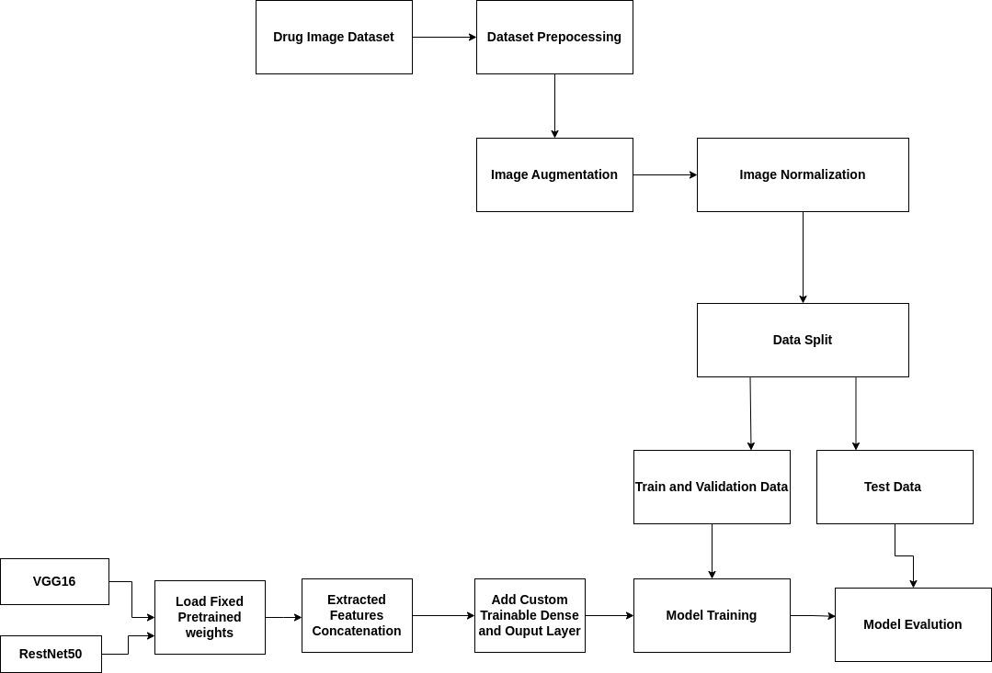**

Figure 3: Designed Framework.

**Designed Framework**

Two independent experiments were carried out using the framework in Figure 3. A multiclass classification for brand recognition and a binary classification for counterfeit detection will classify the medicines into real or fake.

**Drug Image Dataset**

A custom dataset of real and fake medicines was created using the logos of 10 licensed pharmaceutical companies in Nigeria. The selected companies were considered due to the challenge of limited data. The criteria used to select the companies are high public acceptance and mass production of pharmaceutical products. The medicine packs were collected from NAFDAC by taking front-view pictures of the packs which contained the brand logo, color, texture, and the NAFDAC number of the brand. However, a limited number of fake medicine packs were obtained from NAFDAC. Other counterfeit logos were generated by subtly modifying authentic logos using a photo editing suite. The alterations that were made to real logos were based on observations from previous studies of collected fake logos which include utilizing partial logos or altering specific alphabets in the process (Ferdosi et al., 2021).

To create the dataset (real medicines) used for the experiments, 10 selected pharmaceutical brands were captured with each containing 4 different classes of medicine images. Brand logo, medicine name, and NAFDAC numbers. The same brand of medicines was used to create the dataset (fake medicine) used for the experiment, but this category only contained the logo and the medicine names. The dataset for multiclass classification consists of 20 classes, 10 classes for real brands and the other 10 classes for the corresponding fake brands. The binary classification dataset consists of 2 classes of real and fake medicine images

The images were captured using a camera showing the logos, medicine names, and NAFDAC numbers of each medicine brand. The collection of images corresponds to a particular brand. Tables 1 and 2 show the labeled mappings for classes present in the multi-classification dataset and binary class dataset and the respective number of images captured. The focus is to identify and classify sampled medicine.

**Table 1: Label Mappings for Classes Present in the Dataset for Binary Classification.**

|  |  |  |  |
| --- | --- | --- | --- |
| Label/No | Class | Number of images | Sample Image |
| 0 | Real | 2640 | C:\Users\USER\Desktop\Multi_Class_Classification\GSK\1714819944384 - Copy.jpg C:\Users\USER\Desktop\Multi_Class_Classification\M & B\1714834820186.jpg C:\Users\USER\Desktop\Multi_Class_Classification\Emzor\IMG20240503113819.jpg |
| 1 | Fake | 2640 | C:\Users\USER\Desktop\Multi_Class_Classification\GSK_Fake\IMG-20240507-WA0180 - Copy - Copy - Copy (2).jpg C:\Users\USER\Desktop\Multi_Class_Classification\Emzor_Fake\IMG-20240507-WA0078 - Copy (3) - Copy.jpg |
|  | **Total** | **5280** |  |

**Table 2: Label Mappings for Classes Present in the Dataset for Multi-Class Classification.**

|  |  |  |  |
| --- | --- | --- | --- |
| **Label/No** | **Class or Drug companies** | **Number of images** | **Sample Image** |
| 0 | M&B\_Fake | 264 | C:\Users\USER\Desktop\Multi_Class_Classification\M&B_Fake\IMG-20240508-WA0050.jpgC:\Users\USER\Desktop\Multi_Class_Classification\M&B_Fake\IMG-20240508-WA0042 - Copy - Copy (2).jpg |
| 1 | Sun\_Pharm\_Fake | 261 | C:\Users\USER\Desktop\Multi_Class_Classification\Sun_Pharm_Fake\IMG_20240129_165021 (2) copy.jpgC:\Users\USER\Desktop\Multi_Class_Classification\Sun_Pharm_Fake\IMG_20240129_165043 (2) copy.jpg |
| 2 | Fidson\_Fake | 260 | C:\Users\USER\Desktop\Multi_Class_Classification\Fidson_Fake\IMG-20240507-WA0132 - Copy - Copy.jpgC:\Users\USER\Desktop\Multi_Class_Classification\Fidson_Fake\IMG-20240507-WA0175 - Copy (4) - Copy - Copy.jpg |
| 3 | Juhel\_Fake | 262 | C:\Users\USER\Desktop\Multi_Class_Classification\Juhel_Fake\IMG_20240129_1113373 copy.jpgC:\Users\USER\Desktop\Multi_Class_Classification\Juhel_Fake\IMG_20240129_1113372 copy.jpg |
| 4 | GSK\_Fake | 268 | C:\Users\USER\Desktop\Multi_Class_Classification\GSK_Fake\IMG-20240507-WA0180 - Copy - Copy - Copy (2).jpgC:\Users\USER\Desktop\Multi_Class_Classification\GSK_Fake\IMG-20240507-WA0185 - Copy - Copy - Copy - Copy.jpg |
| 5 | Sagar\_Fake | 264 | C:\Users\USER\Desktop\Multi_Class_Classification\Sagar_Fake\IMG_20240131_132706 (2) copy.jpgC:\Users\USER\Desktop\Multi_Class_Classification\Sagar_Fake\IMG_20240131_132726 (2) copy.jpg |
| 6 | Emzor\_Fake | 265 | C:\Users\USER\Desktop\Multi_Class_Classification\Emzor_Fake\IMG_20240129_114806 (4) copy.jpgC:\Users\USER\Desktop\Multi_Class_Classification\Emzor_Fake\IMG-20240507-WA0078 - Copy (3) - Copy.jpg |
| 7 | Bliss\_Fake | 266 | C:\Users\USER\Desktop\Multi_Class_Classification\Bliss_Fake\1714925456494.jpgC:\Users\USER\Desktop\Multi_Class_Classification\Bliss_Fake\1714928002218 - Copy (2).jpg |
| 8 | GSK | 268 | C:\Users\USER\Desktop\Multi_Class_Classification\GSK\1714819944384 - Copy.jpgC:\Users\USER\Desktop\Multi_Class_Classification\GSK\1714819944184 - Copy.jpg C:\Users\USER\Desktop\REAL\GSK\IMG_20240129_164842.jpg |
| 9 | Emzor | 265 | C:\Users\USER\Desktop\Multi_Class_Classification\Emzor\IMG20240503113817.jpgC:\Users\USER\Desktop\Multi_Class_Classification\Emzor\IMG20240503113819.jpg C:\Users\USER\Desktop\Multi_Class_Classification\Emzor\IMG20240503113803.jpg |
| 10 | Drugfield\_Fake | 265 | C:\Users\USER\Desktop\Multi_Class_Classification\Drugfield_Fake\IMG_20240505_205921.jpgC:\Users\USER\Desktop\Multi_Class_Classification\Drugfield_Fake\IMG_20240505_210136.jpg |
| 11 | Dana\_Fake | 265 | C:\Users\USER\Desktop\Multi_Class_Classification\Dana_Fake\1714930588500.jpgC:\Users\USER\Desktop\Multi_Class_Classification\Dana_Fake\1714930588406.jpg |
| 12 | M & B | 264 | C:\Users\USER\Desktop\Multi_Class_Classification\M & B\1714834819050 - Copy.jpgC:\Users\USER\Desktop\Multi_Class_Classification\M & B\1714834820023.jpg C:\Users\USER\Desktop\Multi_Class_Classification\M & B\1714834820186.jpg |
| 13 | Dana | 265 | C:\Users\USER\Desktop\Multi_Class_Classification\Dana\IMG2024050314567.jpgC:\Users\USER\Desktop\Multi_Class_Classification\Dana\IMG20240503130424_015.jpg C:\Users\USER\Desktop\Multi_Class_Classification\Dana\IMG20240503130436_01462-6.jpg |
| 14 | Bliss | 266 | C:\Users\USER\Desktop\REAL\Bliss\IMG20240503125038.jpgC:\Users\USER\Desktop\REAL\Bliss\IMG20240503125036.jpg C:\Users\USER\Desktop\Multi_Class_Classification\Bliss\IMG20240503125056_013.jpg |
| 15 | Sagar | 264 | C:\Users\USER\Desktop\REAL\Sagar\IMG_20240131_132706 (2).jpgC:\Users\USER\Desktop\REAL\Sagar\IMG_20240131_132726 (2).jpg C:\Users\USER\Desktop\REAL\Sagar\IMG_20240131_132726 (3).jpg |
| 16 | Sun\_Pharm | 261 | C:\Users\USER\Desktop\REAL\Sun_Pharmacy\IMG_20240129_165021 (2).jpgC:\Users\USER\Desktop\REAL\Sun_Pharmacy\IMG_20240129_165043 (2).jpg C:\Users\USER\Desktop\REAL\Sun_Pharmacy\IMG_20240129_165043 (3).jpg |
| 17 | Juhel | 262 | C:\Users\USER\Desktop\REAL\Juhel\IMG_20240129_1113373.jpgC:\Users\USER\Desktop\REAL\Juhel\IMG_20240129_1113372.jpg C:\Users\USER\Desktop\REAL\Juhel\IMG_20240129_1113231.jpg |
| 18 | Fidson | 260 | C:\Users\USER\Desktop\Multi_Class_Classification\Fidson\Fidson.logo.16.jpgC:\Users\USER\Desktop\Multi_Class_Classification\Fidson\Astymin.19.jpg C:\Users\USER\Desktop\Multi_Class_Classification\Fidson\Astymin.NAFDAC.5.jpg |
| 19 | Drugfield | 265 | C:\Users\USER\Desktop\Multi_Class_Classification\Drugfield\1714812226735.jpgC:\Users\USER\Desktop\Multi_Class_Classification\Drugfield\1714812226751-.jpg C:\Users\USER\Desktop\Multi_Class_Classification\Drugfield\1714812227021 - Copy.jpg |
|  | **Total** | **5280** |  |

**Data Pre-processing**

The ImageDataGenerator in TensorFlow’s Keras API was used for data pre-processing. This library was used to load, pre-process, and augment and all images were set to common image sizes of 224x224 pixels for V16RN-50. Functions like load\_img, img\_to\_array, and flow\_from\_directory were utilized for these tasks.

**Image Augmentation**

Figure 4 illustrates the impact of augmentation and their original image. The Image labeled (a) is the original image without augmentation, while the labels (a1), (a2), (a3), (a4), and (a5) are the respectively augmented versions of the images. The augmented images demonstrate various transformations such as rotating, shifting, shearing, zooming, and flipping which helped in creating a more diverse training set. The study adopted an automatic augmentation strategy from Keras' ImageDataGenerator class embedded within the Keras deep learning library. With ImageDataGenerator, various augmentation functions such as rotation\_range, width\_shifth\_range, height\_shift\_range, shear\_range, zoom\_range, horizontal\_flip, and fill\_mode were defined and applied during data generation and generated six times more samples of the original image samples in each class.

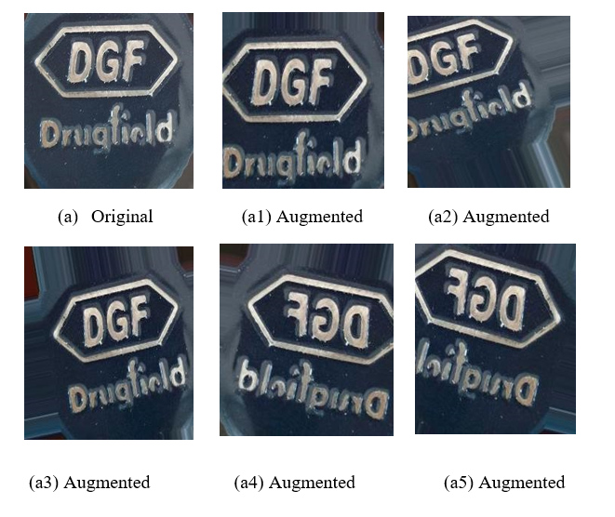

Figure 4: Selected Samples of Augmented Images

For the binary classification task, the dataset is divided into two classes: real and fake medicine images. The distribution of images across these two classes after augmentation is shown in Table 3. In the multi-class classification task, images are categorized based on the specific pharmaceutical brand. The distribution of images for each brand after augmentation is detailed in Table 4.

Table 3: Binary Classification Dataset After Augmentation

|  |  |
| --- | --- |
| **Class** | **Number of Images** |
| Fake | 15840 |
| Real | 15840 |
| **Total** | **31680** |

Table 4: Multi Classification Dataset After Augmentation

|  |  |
| --- | --- |
| **Class** | **Number of Images After Augmentation** |
| M&B\_Fake | 1584 |
| Sun\_Pharm\_Fake | 1566 |
| Fidson\_Fake | 1560 |
| Juhel\_Fake | 1572 |
| GSK\_Fake | 1608 |
| Sagar\_Fake | 1584 |
| Emzor\_Fake | 1590 |
| Bliss\_Fake | 1596 |
| GSK | 1608 |
| Emzor | 1590 |
| Drugfield\_Fake | 1590 |
| Dana\_Fake | 1590 |
| M & B | 1584 |
| Dana | 1590 |
| Bliss | 1596 |
| Sagar | 1584 |
| Sun\_Pharm | 1566 |
| Juhel | 1572 |
| Fidson | 1560 |
| Drugfield | 1590 |
| **Total** | **31800** |

**Image Normalization**

Image normalization was applied to standardize the pixel values of the images, ensuring that they fall within a specific range, typically between 0 and 1. This normalization process is essential for improving the convergence rate of the training process achieving better performance.

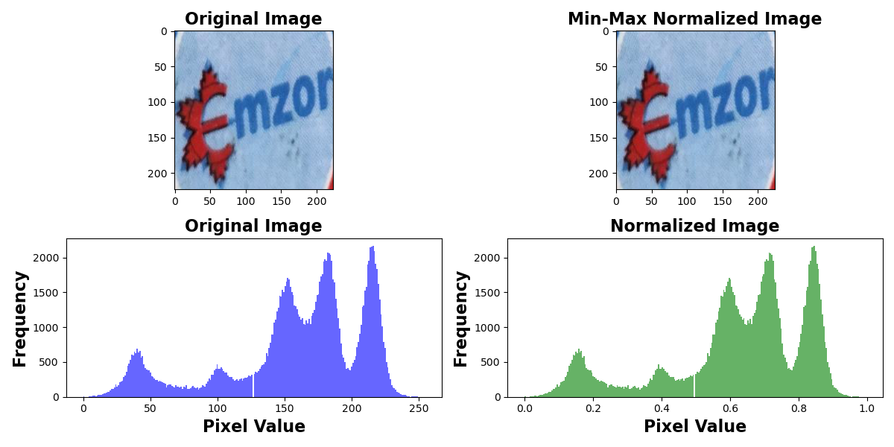

Figure 5: Normalized Image Histogram Example

The histogram in Figure 5 shows the distribution of pixel values before and after normalization. In the "Before Normalization" histogram, pixel values range from 0 to 255, with varying frequencies. After normalization, as shown in the "After Normalization" histogram, pixel values are scaled to fall between 0 and 1, resulting in a more uniform distribution that enhances model stability during training by keeping values within the standardized range. This standardization process helps in maintaining consistency across the dataset and facilitates better learning by the models.

**Dataset Splitting**

The dataset is divided into training, validation, and test sets in a ratio of 70%:15%:15%, respectively, facilitating effective model evaluation

**Pretrained Network Loading**

VGG16 and ResNet50 pre-trained networks were loaded and named V16RN-50, leveraging their respective learned features. The weights of these networks were kept fixed. Extracted features from both networks were concatenated before being passed to the custom layers. This fusion of features enriched the model's understanding, enhancing its predictive capabilities. Custom trainable dense and output layers were added to the concatenated feature set. These layers allow the model to adapt to the specific task and learn task-specific representations.

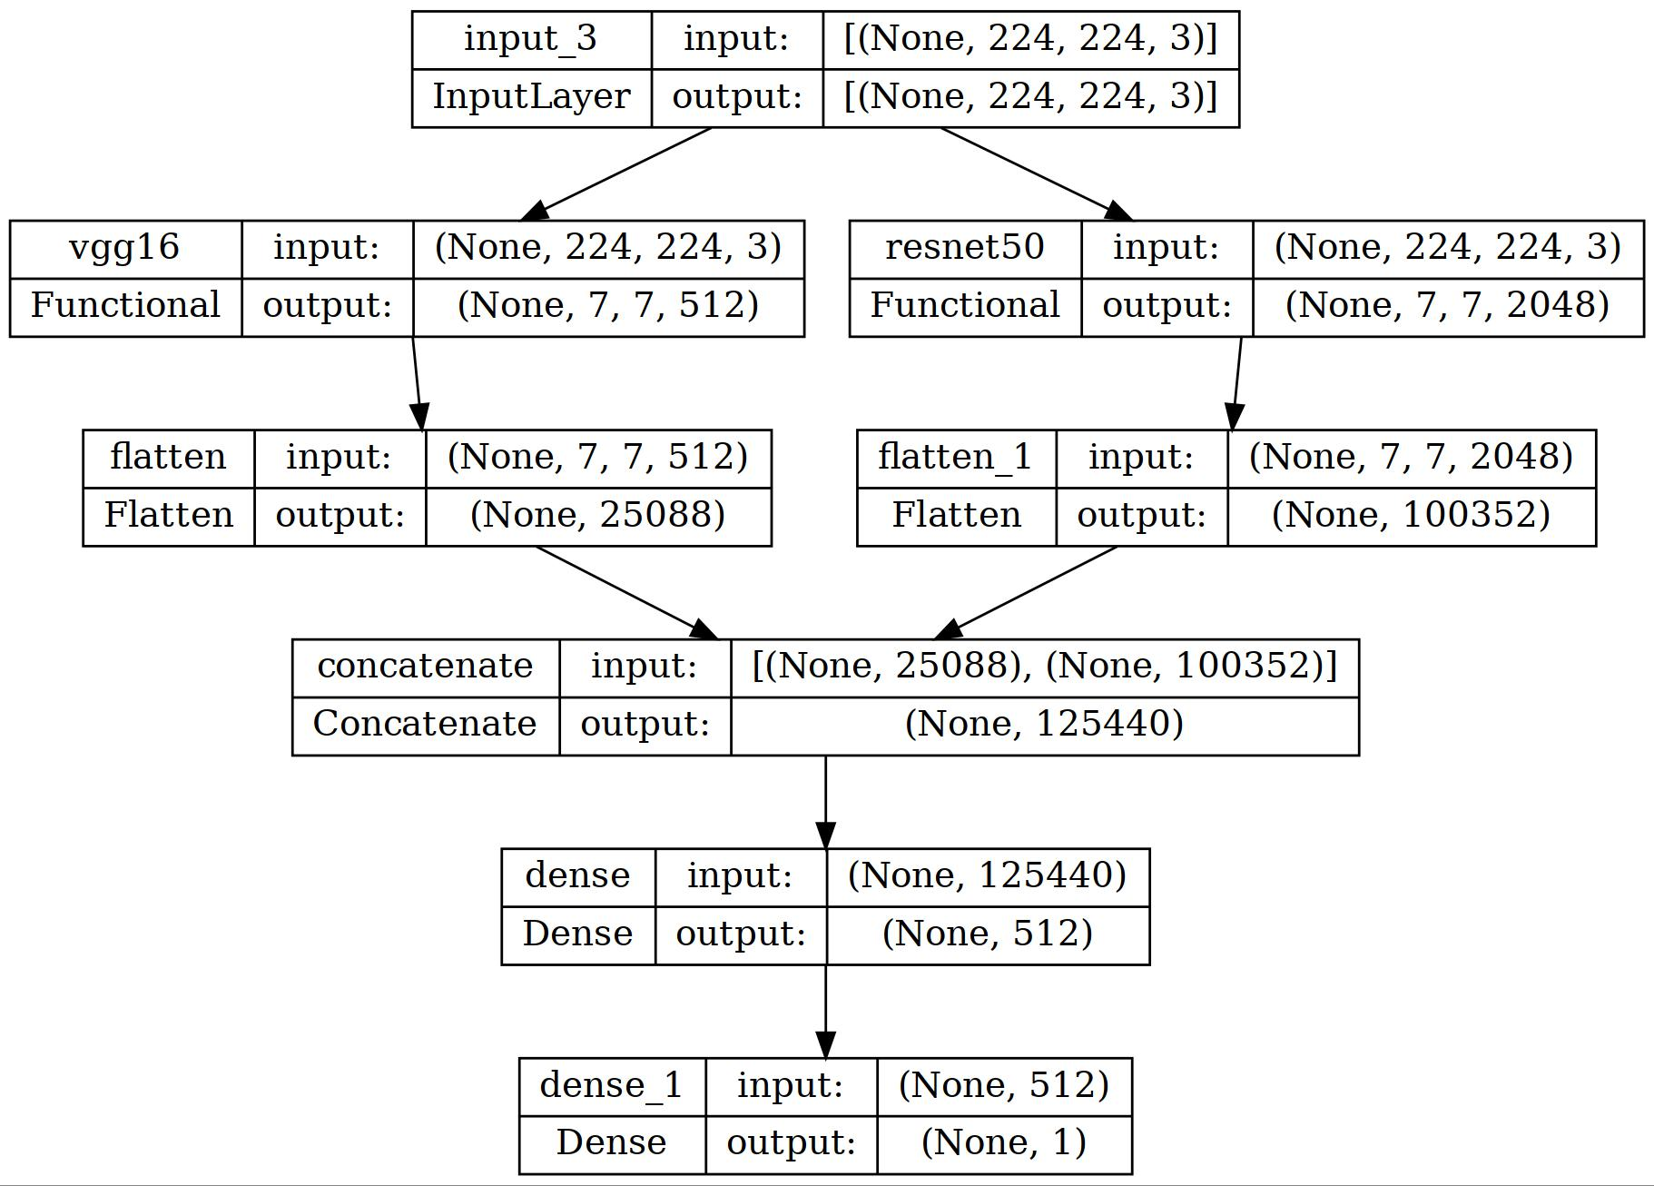

Figure 6: V16RN-50 Model Architecture

Figure 6 shows how the V16RN-50 model was achieved by leveraging the strengths of both architectures. VGG16, known for its simplicity and depth, effectively captured spatial features, while ResNet50, with its residual connections, excels in handling deeper networks without suffering from vanishing gradient problems. The hybrid model was created by combining features extracted from both networks and feeding them into a joint classifier, which was then trained on the classification task. This approach allowed the model to benefit from the complementary features and capabilities of both VGG16 and ResNet50, resulting in enhanced performance and robustness. The combination of the two pretrained networks was achieved using concatenation as shown in Figure 6. The model architecture was visualized using the “plot\_model” library from the keras python package.

**Model Training/Evaluation**

The combined model was trained using the training and validation datasets. During training, model parameters were adjusted to minimize the chosen loss function. The trained model's performance was evaluated using the test dataset, providing insights into its generalization abilities and real-world effectiveness.

**V. RESULTS AND DISCUSSION**

This section presents the results of the experiment. The research was conducted using a V16RN-50 model, leveraging the strengths of VGG16 and ResNet-50 to enhance performance covering the training and evaluation of binary and multi-class classification models, respectively.

***Binary Classification Model Training***

The proposed V16RN-50 model was evaluated on the medicine image binary classification dataset. All models were trained using the adam optimizer with a learning rate of 0.001 and a batch size of 64. The training stopped when validation accuracy reached a stable maximum.

**Evaluation Metrics**

Five primary metrics of accuracy, confusion matrix, precision, recall, and f1 score were used to evaluate the V16RN-50 proposed model.

Accuracy: Accuracy is the overall percentage of correctly classified instances (Alawad et al., 2021) as seen in Equation 3.

(3)

Confusion matrix: The confusion matrix provides an overview of the employed classifier's performance. In addition to false positive (FP) and false negative (FN) values, which show the number of incorrectly classified negative and positive instances, it also displays true positive (TP) and true negative values, which show the number of correct and incorrect instances (Alawad et al., 2021).

Precision: Precision is the ratio of positively predicted instances among the retrieved instances (Gad et al., 2021) as seen in Equation 4.

(4)

Recall: Recall is the ratio of the true positive rate (Gad et al., 2021) as seen in Equation 5.

(5)

F1 score: The F1 score represents the mean between recall and precision values (Alawad et al., 2021) as seen in equation 6.

(6)

**Experimental Results**

The focus of the proposed V16RN-50 model is to improve the detection accuracy of brand classification and the detection of counterfeit medicines. The training and validation loss/accuracy curves for the V16RN-50 model are shown in Figure 7. During the training process, the model's training loss decreases consistently, starting at approximately 0.564 and reaching as low as 0.011 at epoch 50. The validation loss shows a similar trend, starting at 0.433 and reducing to 0.018 at the end of training. This significant reduction in both training and validation loss indicates that the model effectively learns to generalize the features of the dataset without overfitting. The training accuracy increased from 43.6% in the initial epochs to 98.8% by the final epoch, demonstrating a substantial improvement in the model's ability to correctly classify the training data. Similarly, the validation accuracy started at 56.7% and reached 98.1%, showcasing the model's robust performance on unseen data.

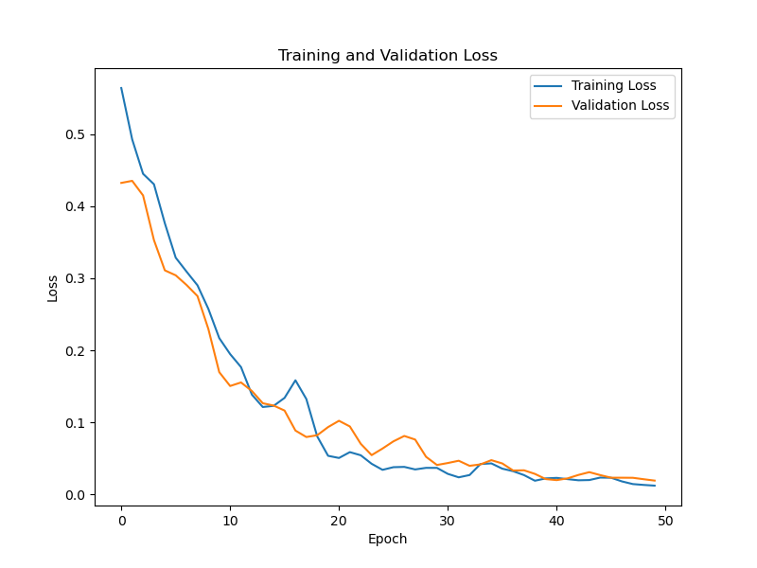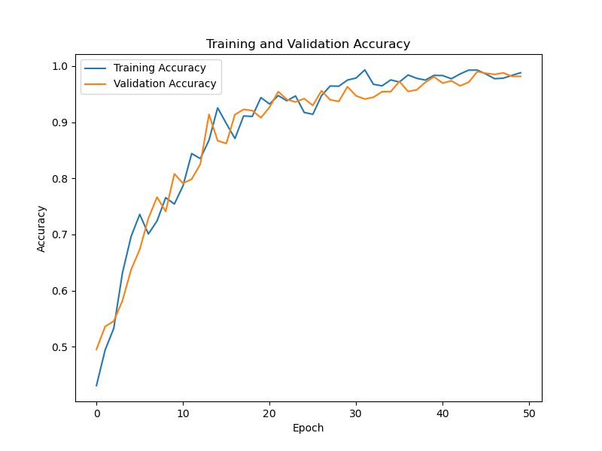

Figure 7: Binary Classification Training and Validation Loss/Accuracy using V16RN-50 Model

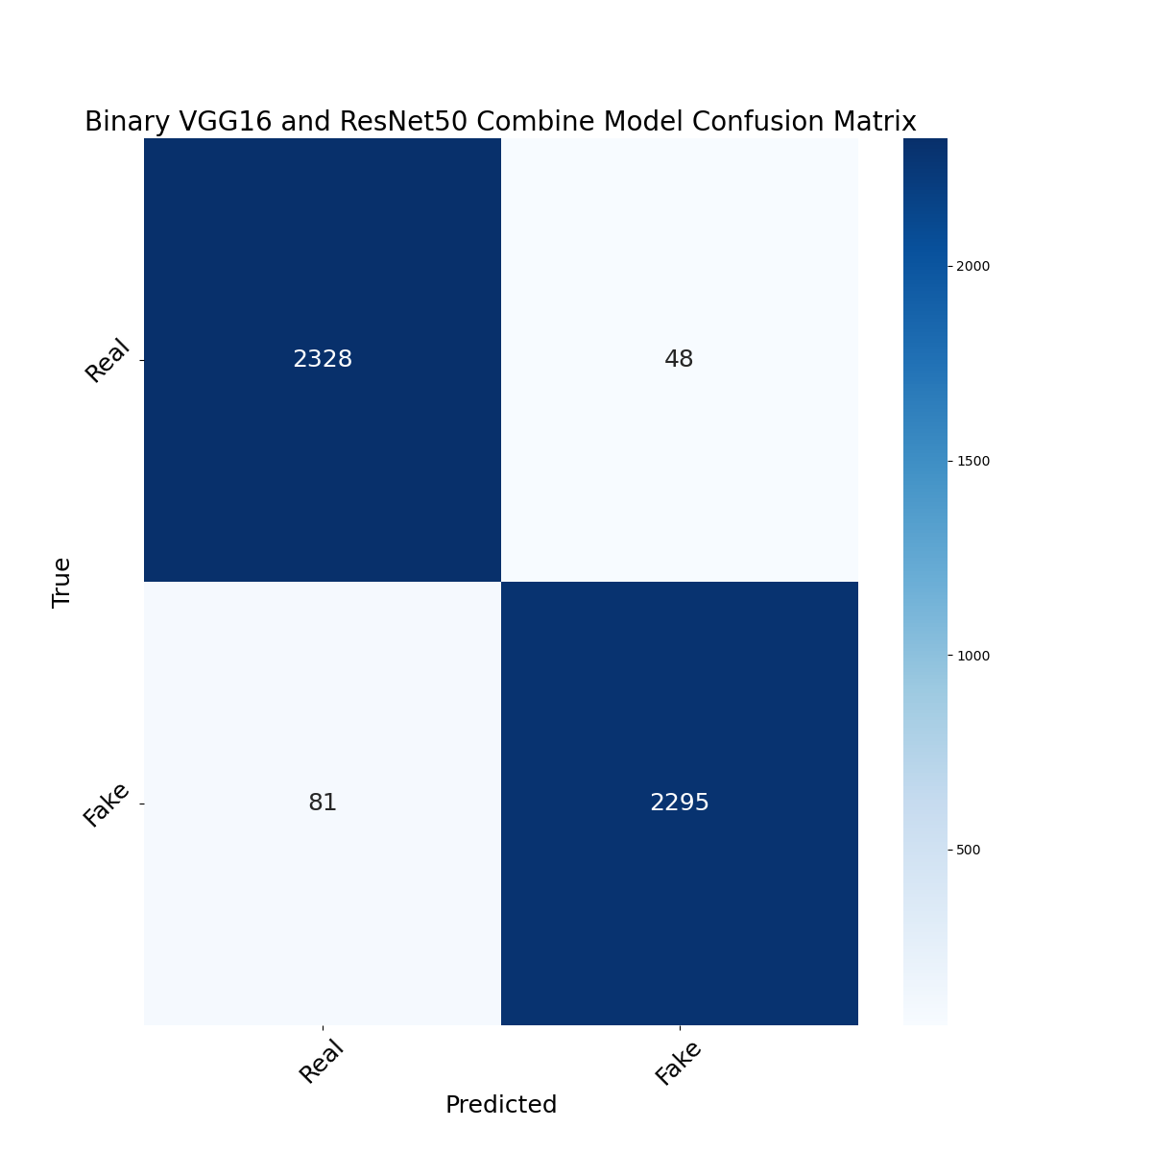

Figure 8: V16RN-50 Model Binary Classification Confusion Matrix

The confusion matrix of the proposed V16RN-50 model, depicted in Figure 8, provides a detailed view of the model's classification performance. Out of 2376 real instances, 2328 were correctly classified as real (TP), while 48 were wrongly classified as fake (FP). Conversely, out of 2376 fake instances, 2295 were correctly classified as fake (TN), while 81 were misclassified as real (FN).

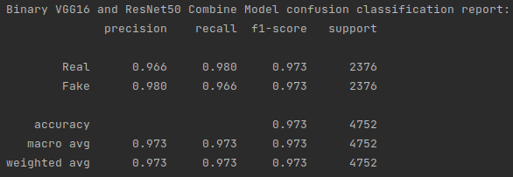

Figure 9: V16RN-50 Model Binary Classification Report

The classification report for the V16RN-50 model, detailed in Figure 9, summarizes the precision, recall, and F1-score for the 'Real' and 'Fake' classes. The precision for the 'Real' class is 0.966 and for the 'Fake' class is 0.980, indicating a high level of accuracy in the positive predictions for both classes, the recall for the 'Real' class is 0.980, and for the 'Fake' class is 0.966, reflecting the model's strong ability to identify the actual positive instances of both classes and both classes have an F1-score of 0.973, highlighting the model's balanced performance in terms of precision and recall.

***Multi-Classification Model Training***

Similarly, the proposed V16RN-50 model was evaluated on the medicine image multi-classification dataset. All models were trained using the adam optimizer with a learning rate of 0.001 and a batch size of 64. The training stopped when validation accuracy reached a stable maximum.

**Experimental results**

Figure 9 illustrates the accuracy and loss curves during the training and validation stages. The training process involved fine-tuning the model on the augmented dataset and evaluating its performance on a validation set.

During the training of the V16RN-50 model, both training and validation losses were monitored to understand the model's learning progress and generalization capability. The loss values for training and validation over the epochs are depicted in Figure 9. The training loss began at 0.4796 and showed a steady decline over the epochs, reaching 0.0466 at epoch 50. This consistent decrease indicated effective learning by the model during training. The validation loss started at 0.4838 and similarly decreased over the epochs, ending at 0.0525. This suggests that the model was not overfitting and was generalizing well to unseen data.

The training accuracy as shown in Figure 10 began at 52.39% and progressively increased, reaching 95.83% by epoch 50. This trend reflects the model's improving ability to learn and classify the training data correctly while validation accuracy started at 60.34% and steadily rose to 94.82% by the final epoch. This consistent increase indicates robust performance on the validation set, reinforcing the model's generalization strength.

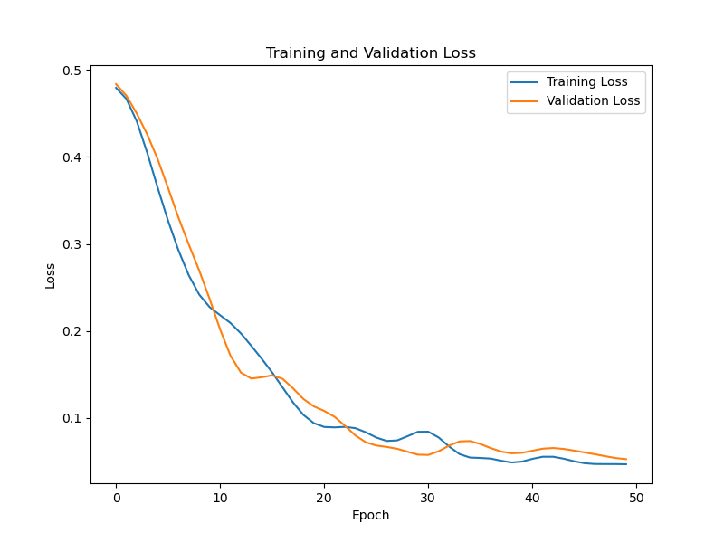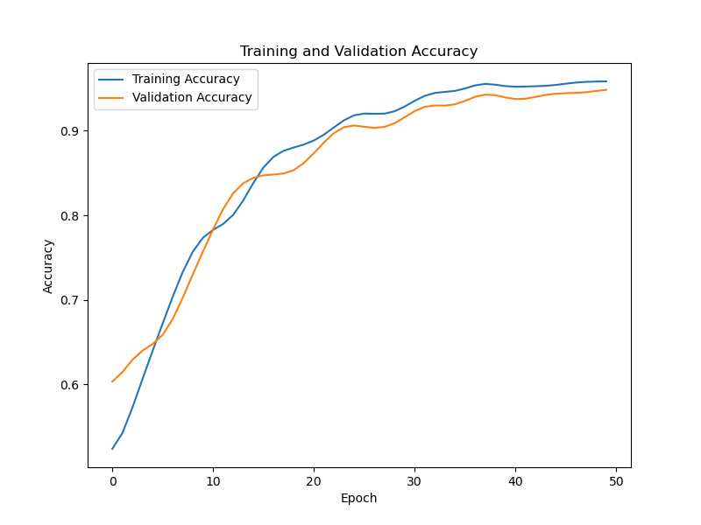

Figure 10: Multi-Classification Training and Validation Loss/Accuracy using V16RN-50 Model

To further analyze the performance, the confusion matrix for the V16RN-50 model was examined. The confusion matrix provides detailed insight into the model's performance across different classes. The confusion matrix reported in Figure 11 shows the true class against the predicted class representing all 20 selected brands of medicine. The dark blue diagonal line shows the correctly classified number of brands which is also referred to as true positive values. All 20 medicine brands reported a true positive value of above 200 which indicates that above 95% of the images were classified to belong to the right class of medicine brand. With GSK\_Fake achieved the highest true positive value of 234 out of 242 instances and the lowest true negative value of 8 while Sagar\_Fake achieved the lowest true positive value of 215 out of 238 instances and the highest true negative value of 23. The remaining classes reported a few varying numbers of incorrectly identified medicine brands that were misclassified into other categories. This shows the model’s effectiveness in counterfeit medicine detection.

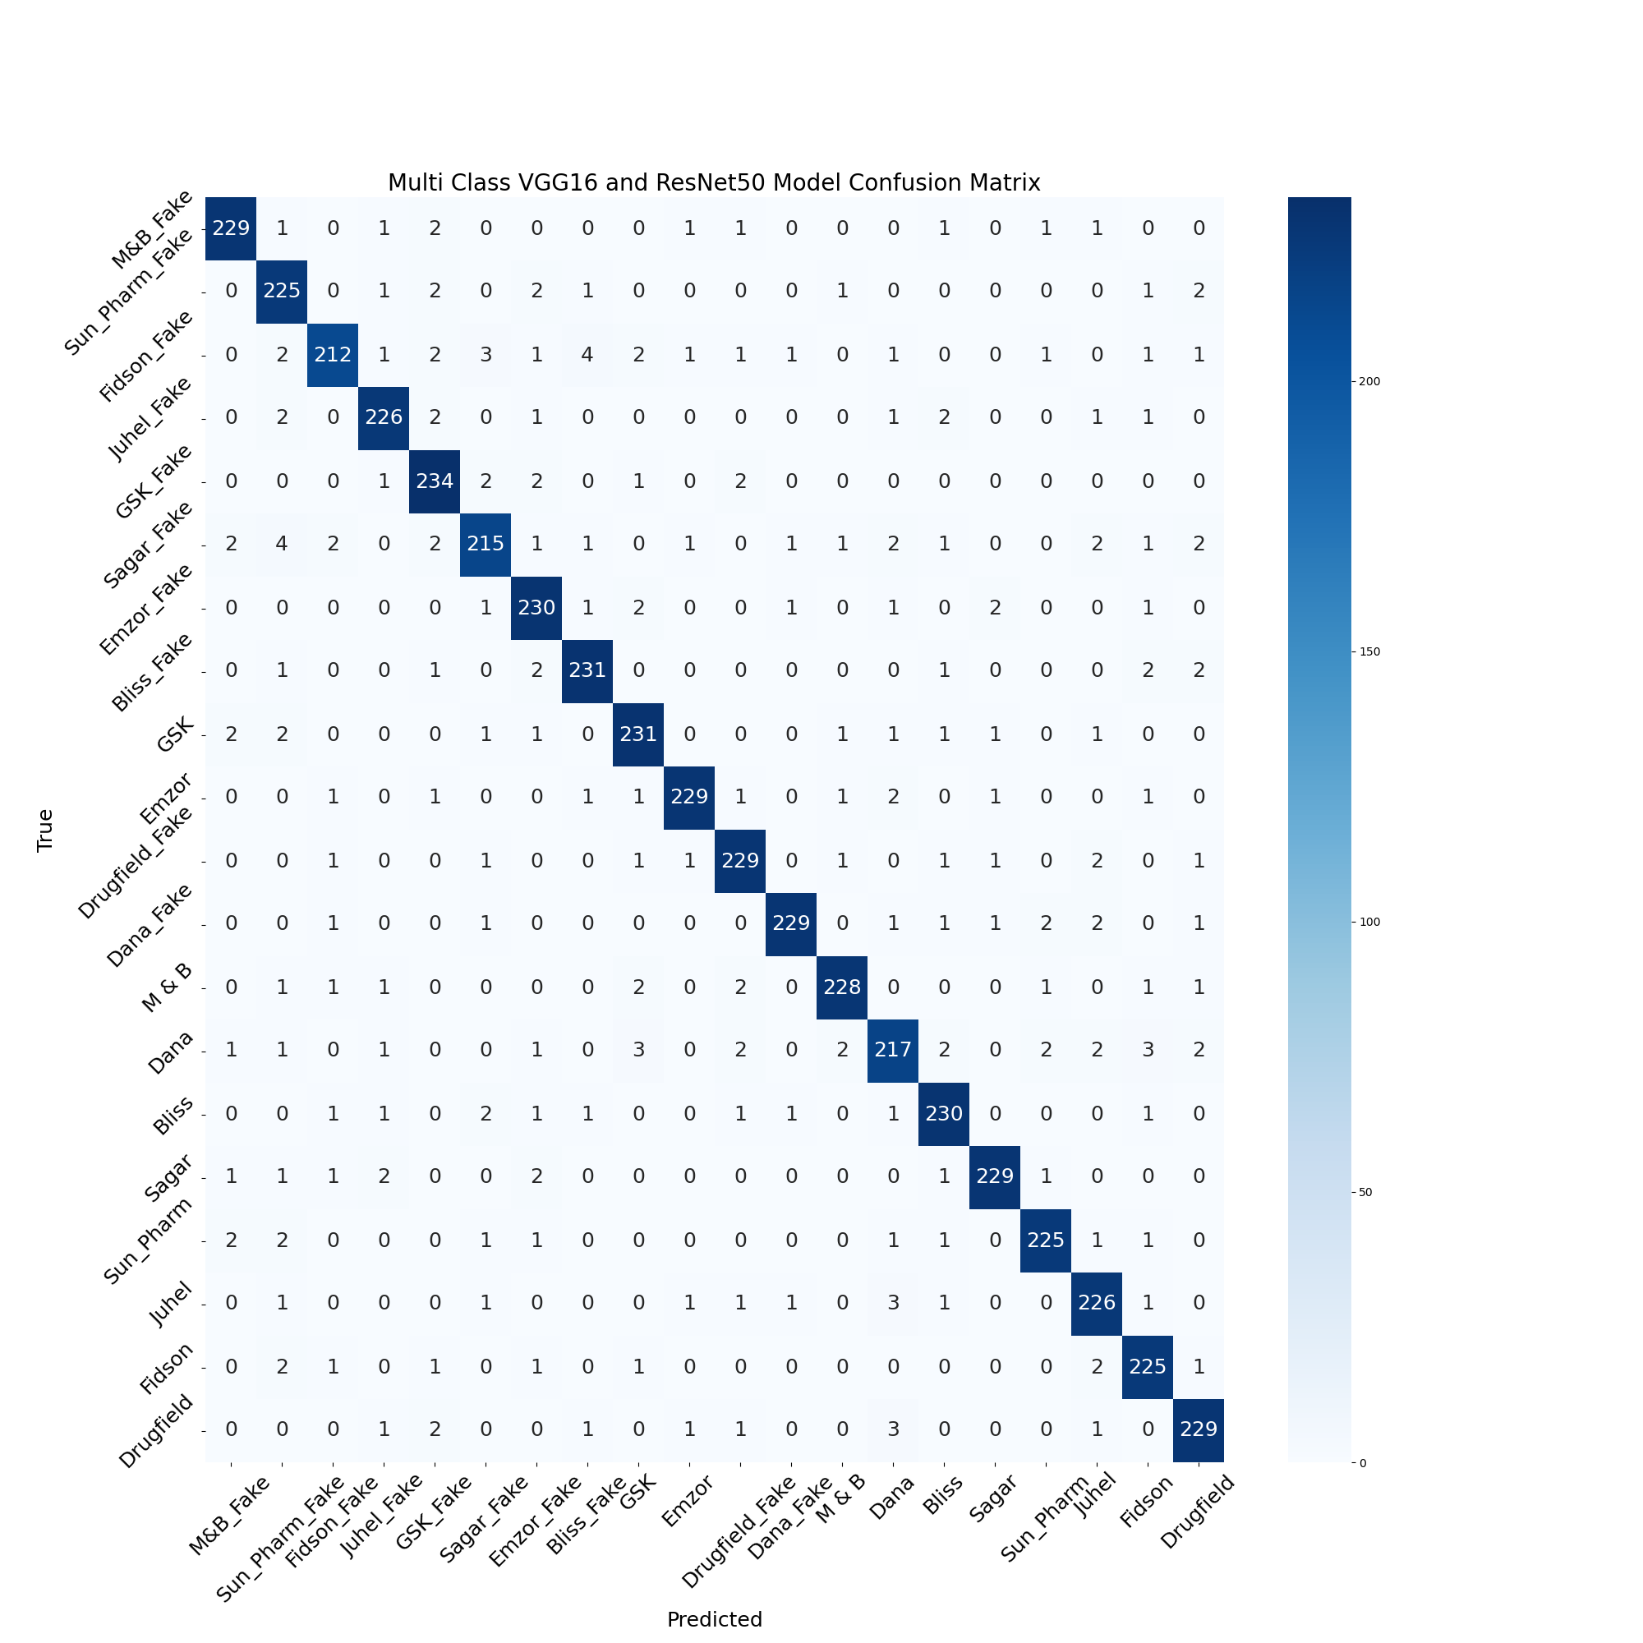

Figure 11: Multi-Classification Confusion Matrix using V16RN-50 Model

The classification report for the V16RN-50 model in Figure 12 provides detailed metrics including precision, recall, f1-score, and support for each class. V16RN-50 model achieved an overall test accuracy of 95.1%. The precision, recall, and F1-score for individual classes were generally high, with the 'Emzor\_Fake' class achieving the highest F1-score of 0.964. The macro and weighted averages for precision, recall, and F1-score were all at 0.951, showcasing the model's balanced performance across all classes.

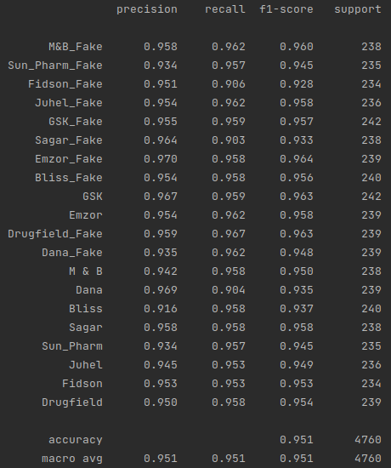

Figure 12: V16RN-50 Model Multi-Classification Report

**Comparison of Binary and Multi-Classification Model Performance**

To compare the performance of binary classification and multi-classification for each model accuracy, macro average precision, macro average recall, and macro average F1-score will be used.

**Table 5: Comparison of Binary and Multi-Classification Model Performance**

|  |  |  |  |  |
| --- | --- | --- | --- | --- |
| **Metric** | **Classification Type** | **VGG-16** (Ferdosi et al., 2021) | **ResNet-50** (Irhebhude et al., 2023) | Proposed **V16RN-50 Model** |
| **Test Accuracy** | Binary | 0.840 | Not Provided | 0.973 |
|  | Multi-Class | 0.960 | 0.793 | 0.951 |
| **Macro Avg Precision** | Binary | Not Provided | Not Provided | 0.973 |
|  | Multi-Class | Not Provided | Not Provided | 0.951 |
| **Macro Avg Recall** | Binary | Not Provided | Not Provided | 0.973 |
|  | Multi-Class | Not Provided | Not Provided | 0.951 |
| **Macro Avg F1-Score** | Binary | Not Provided | Not Provided | 0.973 |
|  | Multi-Class | Not Provided | Not Provided | 0.951 |

The comparison shown in Table 5 is the performance metrics for binary and multi-classifications across three models: VGG-16 (Ferdosi et al., 2021), ResNet-50 (Irhebhude et al., 2023), and the proposed V16RN-50 model. For binary classification, the proposed V16RN-50 model had the highest test accuracy at 97.3%, followed by the VGG-16 which stood at 84.0%. For multi-class classification, VGG16 had a test accuracy of 96.0%, followed by the proposed V16RN-50 model which stood at 95.1%. V16RN-50 model achieved higher accuracy metrics in the binary classification but recorded an accuracy of 0.951 which is 0.009 less than Ferdosi et al. (2021) accuracy of 0.960 in multi-class classification. This was so because the V16RN-50 model had increased complexity in classifying medicine brands as well as identifying the real and fake instances of all brands while Ferdosi et al. (2021) only classified medicine brands in brand recognition.

In binary classification, the proposed V16RN-50 model gave a high score of 97.3% for precision, recall, and F1-score, while for multi-class classification, the proposed V16RN-50 model again had high values of 95.1%, indicating consistently better performance.

The performance metrics indicate that the proposed V16RN-50 model recorded slightly higher performances compared to VGG-16 (Ferdosi et al., 2021) in binary classification. However, it is noticeable that binary classification generally yields higher performance metrics compared to multi-class classification across all models, which is a common trend (Jha et al., 2019) due to the increased complexity and difficulty associated with multi-class problems.

**Discussion of Findings**

The V16RN-50 Model, which combined the VGG16 and ResNet-50 architectures, classified medicine brands and identified counterfeit medicines, with excellent performances. When compared to employing just one pre-trained model, the method performed better.

The proposed approach is further supported by recent research demonstrating the effectiveness of deep learning models for image analysis. Ferdosi et al. (2021) successfully employed VGG16 to identify counterfeit medicines in Bangladesh, highlighting its potential in this domain. Additionally, Irhebhude et al. (2023) showcased the power of ResNet-50 in the task of diagraph sign language recognition, which is a different type of visual recognition. This demonstrated the versatility of these architectures in extracting meaningful features from images, which can be beneficial for counterfeit medicine detection as well.

By combining VGG16 and ResNet-50 and leveraging transfer learning principles, the study achieved an improvement in the classification of medicine brand recognition and counterfeit medicine detection. This approach offers a promising avenue for further development of robust and reliable systems to combat the problem of counterfeit medicines in Nigeria.

**VI.** **CONCLUSION**

In conclusion, this paper presented a CNN Hybrid approach (V16RN-50 Model) for detecting counterfeit and classifying medicines in Nigeria, utilizing images of medicine packaging (logos, colors, textures) and NAFDAC numbers. The results obtained from the experiments demonstrated the effectiveness of combining two state-of-art CNN transfer learning models. Leveraging the strengths of multiple models improved the overall performance and gained deeper insights into data relationships. In the multi-class classification (brand recognition) experiment, the developed V16RN-50 model achieved an impressive accuracy of 95.1% for accurately classifying medicine brands into 20 different categories. Furthermore, an average precision, recall, and F1-score of 0.951, for all 20 classes showed excellent performance and finally, for this category, the confusion matrix highlighted a high number of true positives and true negatives with only a few instances of misclassification. For counterfeit medicine detection, the V16RN-50 model was able to detect counterfeit medicine using the dataset. An average precision, recall, and F1-score of 0.973 was recorded among different classes. The overall accuracy of the V16RN-50 model in the experiment stood at 97.3% indicating a commendable performance.

Future studies can build upon the foundation laid by this research and contribute to a more comprehensive understanding and effective mitigation of the counterfeit medicine crises by incorporating other deep learning techniques such as recurrent neural networks (RNNs) to analyze text information on the medicine package and develop techniques that can detect counterfeit medicines with different chemical compositions.

**REFERENCES**

Adigwe, O. P., Onavbavba, G., & Wilson, D. O. (2022). Challenges Associated with Addressing Counterfeit Medicines in Nigeria: An Exploration of Pharmacists&rsquo; Knowledge, Practices, and Perceptions. *Integrated Pharmacy Research and Practice*, *11*, 177–186. https://doi.org/10.2147/IPRP.S387354

Alawad, W., Alburaidi, B., Alzahrani, A., & Alflaj, F. (2021). A Comparative Study of Stand-Alone and Hybrid CNN Models for COVID-19 Detection. *International Journal of Advanced Computer Science and Applications*, *12*(6). https://doi.org/10.14569/IJACSA.2021.01206102

Alsallal, M., Sharif, M., Al-Ghzawi, B., & al Mutoki, S. M. M. (2019). *A Machine Learning Techniques to Detect Counterfeit Medicine Based on X-Ray Fluorescence Analyser* (M. H. Miraz, P. S. Excell, A. Jones, S. Soomro, & M. Ali, Eds.; pp. 118–122). IEEE. https://doi.org/10/iCCECE%202018\_2.pdf

Ansari, I., Lee, Y., Jeong, Y., & Shim, J. (2018). Recognition of Car Manufacturers using Faster R-CNN and Perspective Transformation. *Journal of Korea Multimedia Society*, *21*(8), 888–896. https://doi.org/10.9717/kmms.2018.21.8.888

Crews, C. C. E. (2018). Non-destructive detection of counterfeit and substandard medicines using X-ray diffraction. *Unpublished Doctoral Thesis*.

Daoud, E., Vu, D., Nguyen, H., & Gaedke, M. (2020). Improving Fake Product Detection Using AI-Based Technology. *Proceedings of the 18th International Conference on E-Society (ES 2020)*, 119–125. https://doi.org/10.33965/es2020\_202005L015

Davison, M. (2011). *Pharmaceutical Anti‐Counterfeiting: Combating the Real Danger from Fake Drugs* (1st ed.). Wiley. https://doi.org/10.1002/9781118023679

Ekeh, C. M., & Adekoya, H. O. (2021). Awareness and Adoption of Drug Mobile Authentication Service: A Conscious Approach in Eradication of Fake and Counterfeit Drugs in Nigeria | KIU Journal of Social Sciences. *KIU Journal of Social Sciences, .*, *7*(1), 43–51.

Ezigbo, O. (2023, October 30). *NAFDAC Seeks Tougher Sanctions Against Peddlers of Substandard Medicines*. Arise News. https://www.arise.tv/nafdac-seeks-tougher-sanctions-against-peddlers-of-substandard-medicines/

Ferdosi, B. J., Sakib, M. A., Islam, Md. S., & Dhar, J. (2021). Identifying Counterfeit Medicine in Bangladesh Using Deep Learning. In A. Zimmermann, R. J. Howlett, L. C. Jain, & R. Schmidt (Eds.), *Human Centred Intelligent Systems* (Vol. 244, pp. 46–55). Springer Singapore. https://doi.org/10.1007/978-981-16-3264-8\_5

Gad, A. R., Nashat, A. A., & Barkat, T. M. (2021). Intrusion Detection System Using Machine Learning for Vehicular Ad Hoc Networks Based on ToN-IoT Dataset. *IEEE Access*, *9*, 142206–142217. https://doi.org/10.1109/ACCESS.2021.3120626

Ghosh, A., Sufian, A., Sultana, F., Chakrabarti, A., & De, D. (2020). Fundamental Concepts of Convolutional Neural Network. In V. E. Balas, R. Kumar, & R. Srivastava (Eds.), *Recent Trends and Advances in Artificial Intelligence and Internet of Things* (Vol. 172, pp. 519–567). Springer International Publishing. https://doi.org/10.1007/978-3-030-32644-9\_36

He, K., Zhang, X., Ren, S., & Sun, J. (2016). Deep Residual Learning for Image Recognition. *2016 IEEE Conference on Computer Vision and Pattern Recognition (CVPR)*, 770–778. https://doi.org/10.1109/CVPR.2016.90

Ibrahim, A. M., Elbasheir, M., Badawi, S., Mohammed, A., & Alalmin, A. F. M. (2023). Skin Cancer Classification Using Transfer Learning by VGG16 Architecture (Case Study on Kaggle Dataset). *Journal of Intelligent Learning Systems and Applications*, *15*(03), 67–75. https://doi.org/10.4236/jilsa.2023.153005

Irhebhude, M., Kolawole, A., & Abubakar, H. (2023). *Digraph Sign Language Recognition Using Residual Network and Support Vector Machine, International Conference on Communication and E-Systems for Economic Stability*, Bauchi, Nigeria, 303-309.

Irhebhude, M., Kolawole, A., & Goshit, N. (2023). *Perspective on Dark-Skinned Emotion Recognition Using Deep-Learned and Handcrafted Feature Techniques. In H. Seyyed Abed (Ed.), Emotion Recognition (pp. Ch. 1). IntechOpen.* [*https://doi.org/10.5772/intechopen.109739*](https://doi.org/10.5772/intechopen.109739)

Islam, I., & Islam, M. N. (2022). Digital intervention to reduce counterfeit and falsified medicines: A systematic review and future research agenda. *Journal of King Saud University - Computer and Information Sciences*, *34*(9), 6699–6718. https://doi.org/10.1016/j.jksuci.2022.02.022

Isles, M. (2017). What’s in a Word? Falsified/Counterfeit/Fake Medicines - The Definitions Debate. *Medicine Access @ Point of Care*, *1*, maapoc.0000008. https://doi.org/10.5301/maapoc.0000008

Jha, A., Dave, M., & Madan, S. (2019). Comparison of Binary Class and Multi-Class Classifier Using Different Data Mining Classification Techniques. *SSRN Electronic Journal*. https://doi.org/10.2139/ssrn.3464211

Klantschnig, G., & Huang, C. (2019). Fake drugs: Health, wealth and regulation in Nigeria <span class="so-article-trans-title" dir="auto"> Translated title: Faux médicaments : santé, fortune et régulation au Nigeria </span>. *Review of African Political Economy*, *46*, 442. https://doi.org/10.1080/03056244.2018.1536975

Krichen, M. (2023). Convolutional Neural Networks: A Survey. *Computers*, *12*(8), Article 8. https://doi.org/10.3390/computers12080151

Kunduraci, M. F., & Kahramanli̇ Örnek, H. (2019). Vehicle Brand Detection Using Deep Learning Algorithms. *International Journal of Applied Mathematics Electronics and Computers*, *7*(3), 70–74. https://doi.org/10.18100/ijamec.578497

Mackey, T. K., & Nayyar, G. (2017). A review of existing and emerging digital technologies to combat the global trade in fake medicines. *Expert Opinion on Drug Safety*, *16*(5), 587–602. https://doi.org/10.1080/14740338.2017.1313227

Motwani, K., Dsouza, R., Dsouza, R., & Jose, J. (2022). *Counterfeit Medicine Detection using Deep Learning*. *9*(3).

Mukherjee, S. (2022, August 18). *The Annotated ResNet-50*. Medium. https://towardsdatascience.com/the-annotated-resnet-50-a6c536034758

Obinna, C., & Olawale, G. (2010, June 11). NAFDAC introduces new anti-counterfeiting technologies. *Vanguard News*. https://www.vanguardngr.com/2010/06/nafdac-introduces-new-anti-counterfeiting-technologies/

Okereke, M., Anukwu, I., Solarin, S., & Sam Ohuabunwa, M. (2021). Combatting Substandard and Counterfeit Medicines in the Nigerian Drug Market: How Industrial Pharmacists Can Rise Up to the Challenge. *INNOVATIONS in Pharmacy*, *12*(3), 15. https://doi.org/10.24926/iip.v12i3.4233

Olaniran, O. D. (2023). An Investigation into NAFDAC Intervention on the Incidence of Fake and Counterfeit Drugs in Nigeria. *Texila International Journal of Public Health*, *11*(3), 107–116. https://doi.org/10.21522/TIJPH.2013.11.03.Art009

Oyetunde, O. O., Ogidan, O., Akinyemi, M. I., Ogunbameru, A. A., & Asaolu, O. F. (2019). Mobile authentication service in Nigeria: An assessment of community pharmacists’ acceptance and providers’ views of successes and challenges of deployment. *Pharmacy Practice*, *17*(2), 1449. https://doi.org/10.18549/PharmPract.2019.2.1449

Sanghi, A., Aayush, Arora, A., & Kaushik, A. (2021). Detecting Fake Drugs using Blockchain. *International Journal of Recent Technology and Engineering (IJRTE)*, *10*(1), 100–109. https://doi.org/10.35940/ijrte.A5744.0510121

Sherma, L. K., Monika Waksmundzka-Hajnos, Joseph (Ed.). (2013). *Thin Layer Chromatography in Drug Analysis*. CRC Press. https://doi.org/10.1201/b15637

Shinde, S. R., Bhavsar, K., Kimbahune, S., Khandelwal, S., Ghose, A., & Pal, A. (2020). Detection of Counterfeit Medicines Using Hyperspectral Sensing. *2020 42nd Annual International Conference of the IEEE Engineering in Medicine & Biology Society (EMBC)*, 6155–6158. https://doi.org/10.1109/EMBC44109.2020.9176419

Simonyan, K., & Zisserman, A. (2015). *Very Deep Convolutional Networks for Large-Scale Image Recognition* (arXiv:1409.1556). arXiv. http://arxiv.org/abs/1409.1556

Singh\*, S., Dubey, S., Singhal, P., & Kumar, Dr. R. (2020). Brand Detection System using Deep Learning. *International Journal of Innovative Technology and Exploring Engineering*, *9*(9), 497–500. https://doi.org/10.35940/ijitee.I7630.079920

Sreeja, K., Yadav, I. S. H., & Nagaraju, G. (2023). Logo Detection using Machine Learning. *INTERANTIONAL JOURNAL OF SCIENTIFIC RESEARCH IN ENGINEERING AND MANAGEMENT*, *07*(01). https://doi.org/10.55041/IJSREM17310

Tey, H.-C., Chong, L. Y., & Chong, S.-C. (2023). Comparative Analysis of VGG-16 and ResNet-50 for Occluded Ear Recognition. *JOIV : International Journal on Informatics Visualization*, *7*(4), 2247–2254. https://doi.org/10.30630/joiv.7.4.02276

Ting, H.-W., Chung, S.-L., Chen, C.-F., Chiu, H.-Y., & Hsieh, Y.-W. (2020). A drug identification model developed using deep learning technologies: Experience of a medical center in Taiwan. *BMC Health Services Research*, *20*(1), 312. https://doi.org/10.1186/s12913-020-05166-w

Trenfield, S. J., Xian Tan, H., Awad, A., Buanz, A., Gaisford, S., Basit, A. W., & Goyanes, A. (2019). Track-and-trace: Novel anti-counterfeit measures for 3D printed personalized drug products using smart material inks. *International Journal of Pharmaceutics*, *567*, 118443. https://doi.org/10.1016/j.ijpharm.2019.06.034

Upadhyay, A., Bhargava, A., & Kumar, J. S. (2023). *Investigating to detect the fake medicines using blockchain technology* [Preprint]. In Review. https://doi.org/10.21203/rs.3.rs-3003120/v1

WHO. (2018, January 31). *Substandard and falsified medical products*. https://www.who.int/news-room/fact-sheets/detail/substandard-and-falsified-medical-products

Yamashita, R., Nishio, M., Do, R. K. G., & Togashi, K. (2018). Convolutional neural networks: An overview and application in radiology. *Insights into Imaging*, *9*(4), Article 4. https://doi.org/10.1007/s13244-018-0639-9